Grid World Experiments
Metrics
Policy Accuracy is a percentage that defines how close the learning policy is to the optimal policy. It is calculated by comparing the current actions with the highest Q-values in each state with the actions chosen by the optimal policy. For example, if a state has 3 actions and the optimal policy says the second and third actions are equally optimal, then the Q-values for those second and third actions must be equal, and higher than the first for the state to be considered accurate and increase the policy accuracy percentage. Therefore, the policy accuracy metric can increase and decrease as the agent is learning, and is not considering the convergence to the true Q-values for an action.

Average reward per 100 actions records the rewards the agent received within the last 100 actions, or the total amount of actions taken if the total is less than 100, and calculates the average reward received per action taken. This value can be expected to increase when exploiting the current policy, and to decrease when exploring the environment.

Exploration Value is the value that determines whether the agent should exploit the policy or explore the environment. Values of less than 1 will favour actions with low Q-values, whereas values greater than 1 will favour actions with higher Q-values.

Iterations is the amount of actions the agent has taken.

(1 – reportExpr3 file)

To demonstrate and experiment with the variables and strategies of reinforcement learning, an environment has been created below. The agent is the black square, and begins in the top left corner of the grid. Two reward states exist, as shown in red text. This environment has a small amount of states and actions, however the 2 different reward states and various paths that can lead to the rewards results in the agent needing to learn which actions are most profitable.

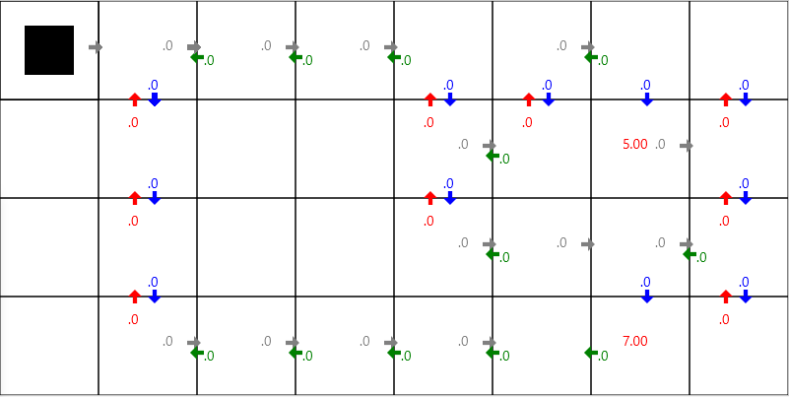

The optimal policy is shown below, calculated via value iteration. Every state has an arrow leading out from it, which represents the action that is expected to result in the highest reward, when the rest of the policy is followed. This is the policy that the agent should, hopefully, eventually learn – or learn enough of the policy to yield acceptably high rewards. The red text represents the value for each state.

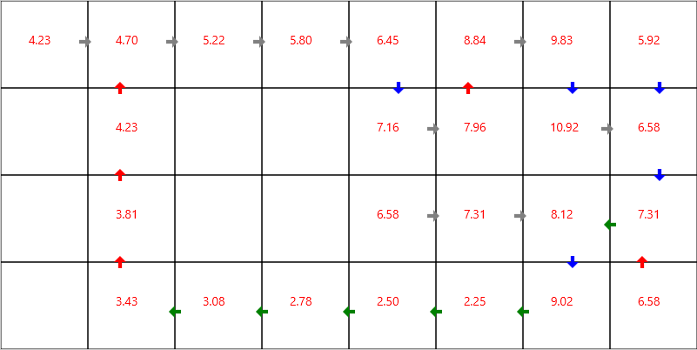

To begin, the Q-values will be initialized randomly between 0 and 20 for each action, and the discount variable set to 0.9. This first graph shows the policy accuracy metric over 2000 iterations. The accuracy begins at around 70%, due to the random initial Q-values. The accuracy jumps up and down for the first ~750 actions, and then steadily increases to reach full accuracy at about 1900 iterations.

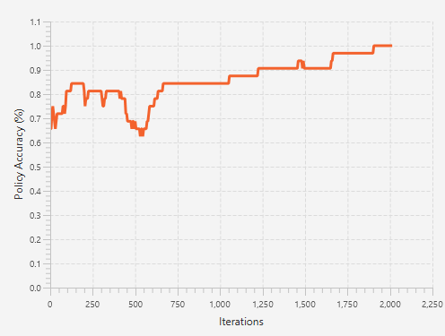

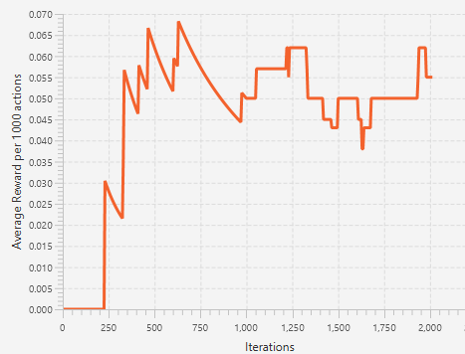
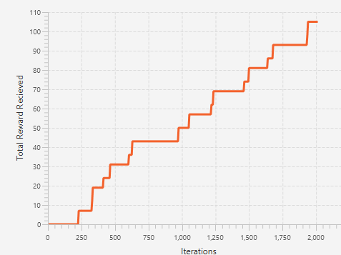

Q-learning method – Exploration value of 2.00 Results

